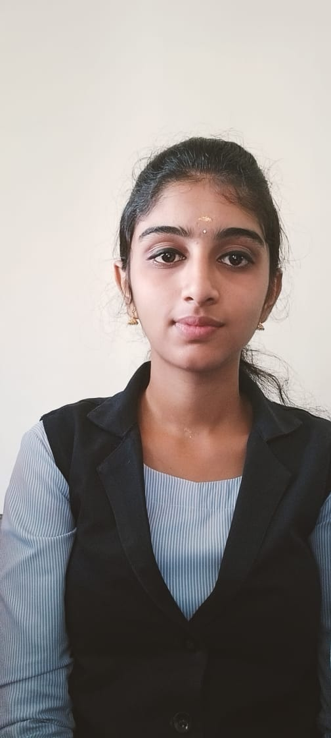

**HELLO I AM A FRESHER**

**KRISHNA PRIYA L**

Email id: krishnapriyalakshmanan7@gmail.com

contact no:6369557408

Date of Birth 02/12/2003

Gender female

Nationality Indian

Marital Status Single

Languages Known Tamil, English

SUMMARY:

Fresher with a degree in from Government Arts and Science College Gudalur, flexible,

organized individual with leadership qualities seeking Opportunity to grow consistently

with commitment and dedication towards my work and company.

**HOBBIES:**

reading books

listening to music

Education:

Bsc.Computer science

Government Arts and Science

College Gudalur , Bharathiar University

Skills

Analytical thinking

Problem solving

Critical Thinking

Declaration:

I hereby declare that the above mentioned information is correct upto to my knowledge.